**Splash**

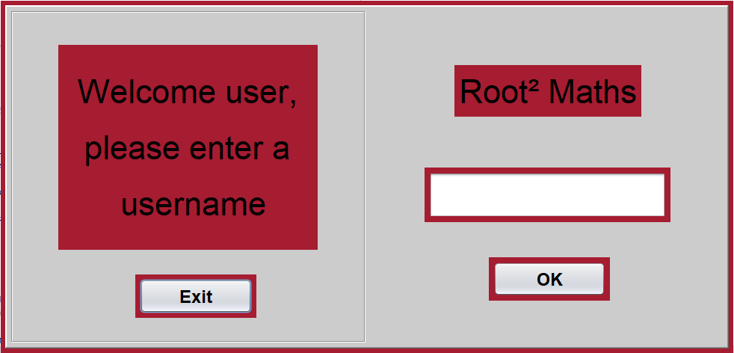

The Splash screen opens with a message asking the user to enter a username. When the user enters their username, the screen closes and continues to the menu screen.

**Menu**

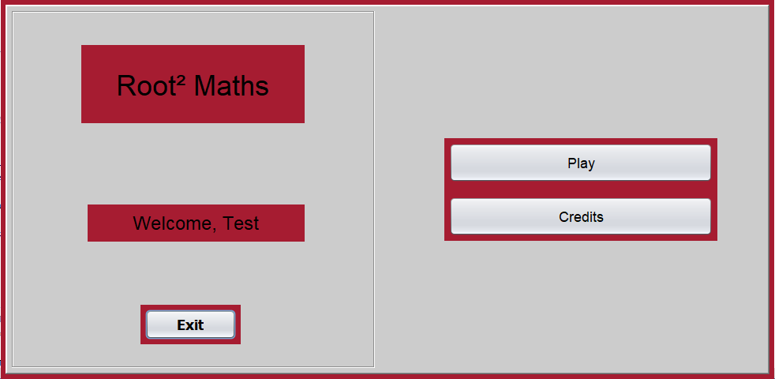

The menu screen displays a welcome message with the user’s username as well as a play button and a credits button.

**Levels**

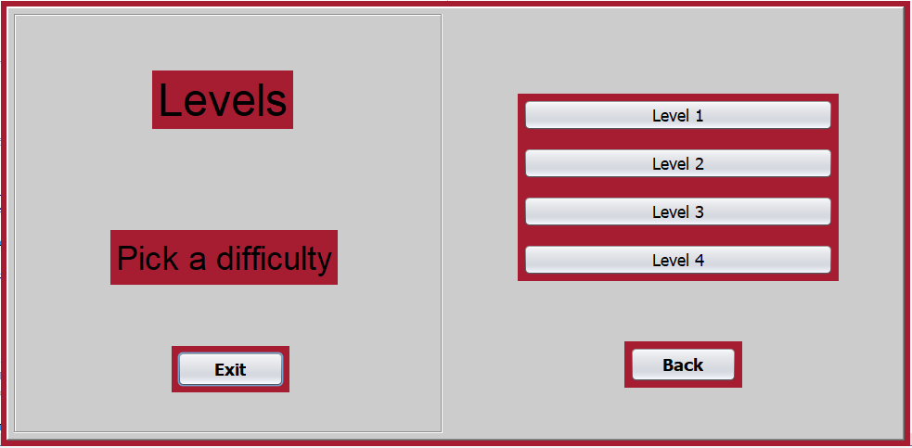

Once the user clicks the play button, they are greeted by a level selection screen. Each level increases in difficulty with an extra level for users who are will to test their math skills. The back button allows the user to go back to the menu page.

**Credits**

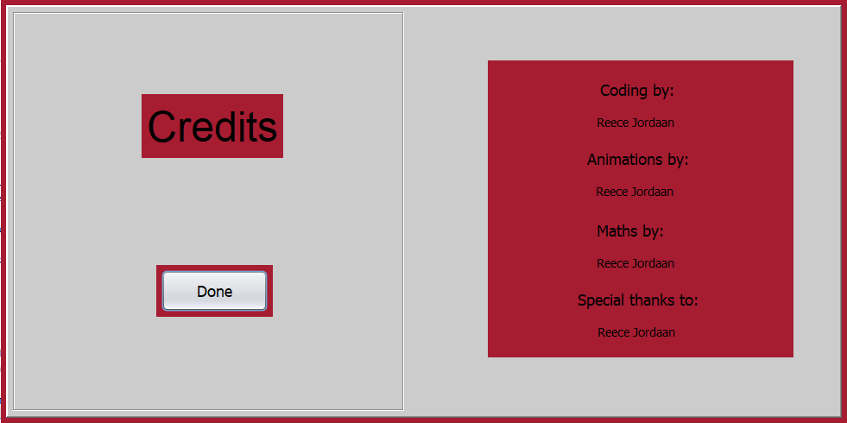

The credits page displays the program credits. The done button returns the user to the menu page.

**Level Start Page**

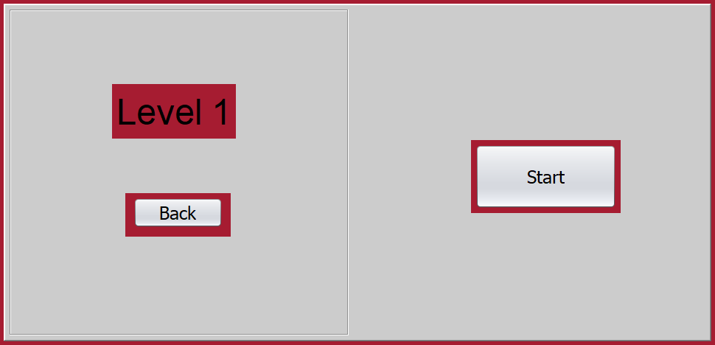

Each level has a start page which allows the user to get ready to start the level. The start button begins the sequences on the game page.

**Level Play Page**

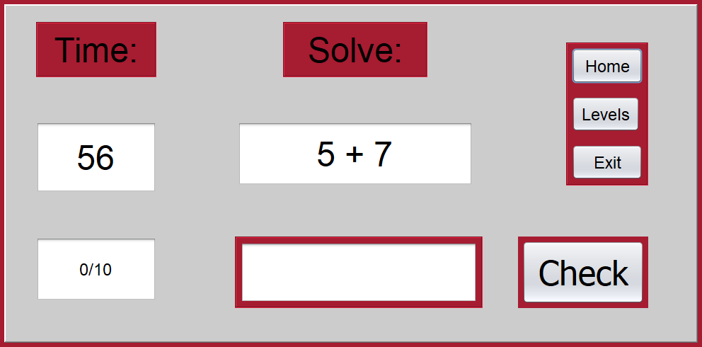

The level play page consists of a timer that counts down from 60, a counter to count the sums you have gotten correct, the question box which displays the question that has to be solved, an answer box where the user can enter a value, a home button which returns the user to the menu, a levels button which allows the user to return to the level selection page and a check button which checks the user’s answer.

**Level Results Page**

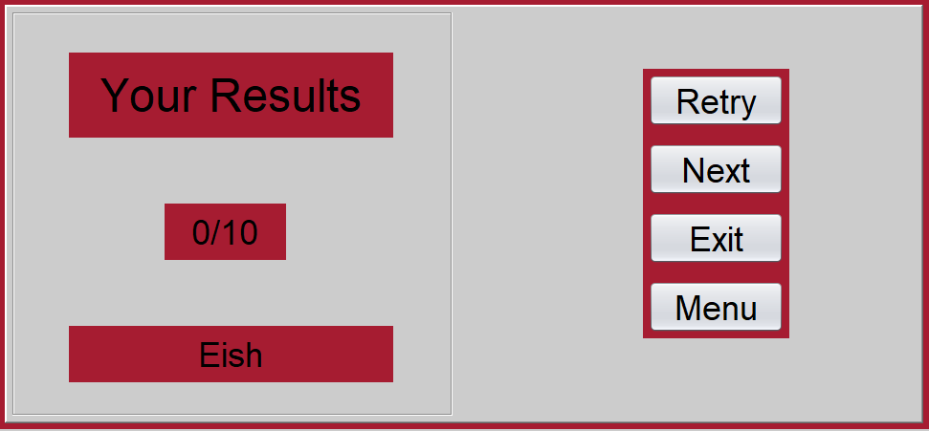

The level results page shows the user’s result, a comment, a retry button which allows the user to replay the level a next button which allows the user to advance to the next level and a menu button which returns the user to the menu.

**Sequencing**

